Terms of Use
Panoramic Images of Iowa

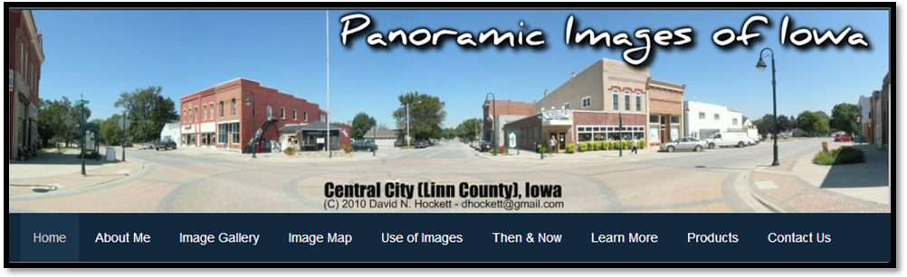
Use of the images found on this site (www.panoramicimagesofiowa.com) are free and encouraged to be used subject to the conditions noted below:
When using images in your website, blog, publication, report and/or presentation please source the photograph(s) as follows:
"Panoramic Images of Iowa by David N. Hockett" and include the following website address:
"www.panoramicimagesofiowa.com"
Failure to properly source or removing /altering copyright information on the images will be considered as a copyright infringement of original artwork by David N. Hockett. Use of the images can be terminated at anytime for any reason with written notice from David N. Hockett. Use of the image(s) will have to cease immediately following notice from David N. Hockett.
Republication of images for commercial use (i.e. magazine, books and or other commercial products) must receive written permission from David N. Hockett.
If you should have any questions regarding the use of images found on this site please feel free to contact me at dhockett@gmail.com.
Please Note: I do not own or control any of the historical images found on this site. They are readily available online through a variety of sources, most notably the Library of Congress Archives.

